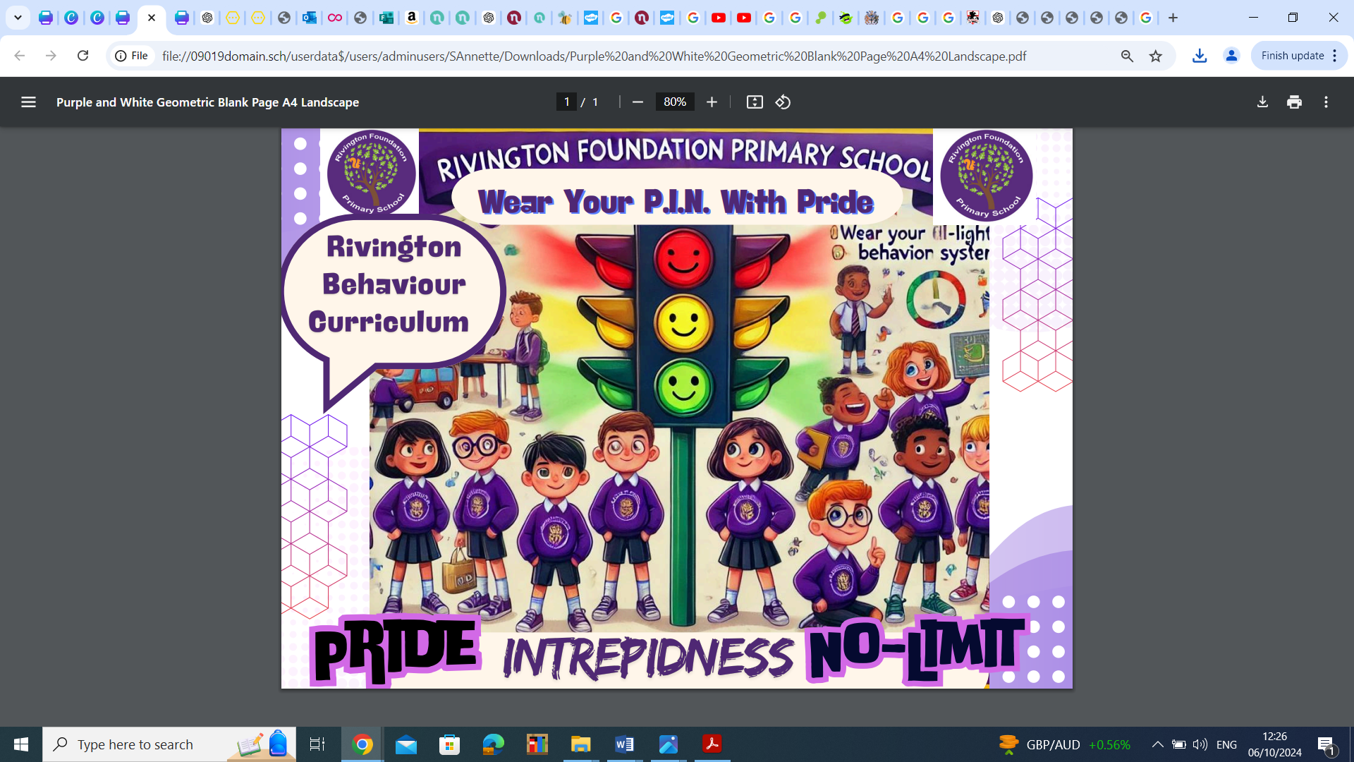

The Rivington Foundation Primary Behaviour Curriculum

2025-26

**Overview of Content**

|  |  |  |  |  |  |  |
| --- | --- | --- | --- | --- | --- | --- |
|  | **Autumn 1** | **Autumn 2** | **Spring 1** | **Spring 2** | **Summer 1** | **Summer 2** |
| **All Year**  **Groups From**  **Nursery to Y6** | Explicit teaching of the full behaviour  curriculum content | Ongoing revision of content | Longer recap of the behaviour curriculum | Ongoing revision of content | Longer recap of the behaviour curriculum | Ongoing revision of content |

# Introduction

At Rivington Foundation Primary School Primary we develop children’s character through our behaviour curriculum. In order to build character, we define the behaviours and habits that we expect students to demonstrate. We want to support our pupils to grow into adults who are polite, respectful, and grateful - and who always consider others. We believe that as pupils practise these behaviours, over time they become automatic routines that positively shape how they feel about themselves and how other people perceive them.

# Teaching the curriculum

The curriculum is taught explicitly during the first week in Autumn term alongside the traditional National Curriculum subjects. Children should learn the content of the curriculum so that they can recall the information and act upon it. At the start of each term, the behaviour curriculum is revisited with pupils and will continue to be reinforced throughout the year. As with other curriculum content, this should be taught using explicit teaching based on the ten principles of instruction from Barak Rosenshine including regular quizzing to check and strengthen retention. Teachers will also demonstrate these behaviours and ensure pupils have time to practise these (particularly in the first few days of term). For example, a lining up order should be taught in the classroom but must be reinforced in different locations and times throughout the school day e.g. at lunchtime. It is expected that all pupils will know this content.

# Adaptations

While this curriculum is for all pupils it will be applied differently in different year groups depending on pupils’ ages and may be applied differently depending on individual pupils’ SEND needs. Sensitivity must be applied at all times when teaching the curriculum.

**Curriculum Content**

|  |
| --- |
| **Curriculum content to be covered in depth in Autumn Term 1 and revisited throughout the year** |
| **Behaviour**  Know that there are three behaviour expectations in school. These are to   * **Be Respectful** * **Be Responsible** * **Be Safe**   Know the following examples of these three principles:   |  |  |  | | --- | --- | --- | | **Be Respectful** | **Be Responsible** | **Be Safe** | | Say please and thank you  Hold doors open for people  Talk kindly to other pupils  Say good morning/ afternoon to adults  Respect others right to learn  Respect school property by looking after it  Use a calm and polite tone of voice  Value differences  Follow teacher instruction | Completing homework on time Remembering to bring equipment to school  Wearing correct school uniform  Tidying up your own workspace and the classroom  Accepting responsibility if you make a mistake and saying sorry | Sitting sensibly in the classroom  Walking through corridors  Playing games that do not become too physical.  Using calm and respectful tones when we communicate. | |

**Our Routines**

Our staff use a **silent signaller** to gain the attention of the class. This is done by raising one hand. When pupils see this, they should respond by being silent and responding with STAR.

* **S** - Sitting or standing up **straight**
* **T** - **Tracking** the teacher
* **A** - **Attention** at all times
* **R** - **Respect** towards others

## Wonderful Walking

Know that we walk around school using **Wonderful Walking**

Know that **Wonderful Walking** means:

* Slowly
* Silently
* Single-file

Know that we use **Wonderful Walking** to keep everyone safe in school and to make sure the learning of other children is not disrupted as people move around school.

Lovely Lining-Up

Know that we line-up using Lovely Lining-Up

Know that Lovely Lining-Up means:

* Head forward
* Feet Forward
* Lips Closed

Amazing Assemblies

Know that when we are in assembly we use Amazing Assemblies

Know that Amazing Assemblies means:

* Eyes forward
* Lips closed
* Hands in lap

## Lovely Listening

Know that we use **Lovely Listening** in class. This means that we use STAR -

* **S** - Sitting or standing up **straight**
* **T** - **Tracking** the teacher
* **A** - **Attention** at all times
* **R** - **Respect** towards others

Know that we all do **Fantastic Listening** to ensure everybody is able to learn without distractions. Know that pupils who do not follow school rules will have a consequence for this.

Contributing

Know that we expect all children to contribute in class. Fantastic contributing means:

* Listening to the class teacher or whoever is speaking
* Considering my responses before sharing
* Putting my hand up so I know my teacher knows I want to contribute during whole class discussions
* Sharing answers/contributions in a clear voice using full sentences
* Building on what others have said

## Fantastic Arriving

* Know that I arrive on time to school.
* Know that I walk calmly to our classrooms.
* Know that I greet staff with a smile and a ‘good morning’.
* Know that I hang my coat up, put my lunchboxes on the trolley and water bottle in the box.
* Know that once I have entered the classroom, I do not leave again unless I have asked a member of staff. Know that I sit down in my seat as soon as I have entered the classroom and begin the morning task.

## Transitioning within a lesson and at the end of a lesson

Know that when the teacher signals (1) I should stop what I am doing.

Know that when the teacher signals (2) I should tuck my chair in if seated and stand up if sat down.

Know that when the teacher signals (3) I should move to my table/line up.

Know that when I am lining up, I should be quiet.

Using good manners

Know that I should always say ‘**please’** when I am asking for something.

Know that I should always say ‘**thank you’** when I receive something or someone does something nice for me.

Know that I should say ‘Good morning/afternoon’ to adults if spoken to.

Know that it is important to show **gratitude** to others by thanking people for what they have done for me. Know that a calm and polite tone is respectful.

## Playtime Behaviour

Know that I must walk from my classroom to the playground using Fantastic Walking.

Know that I must play safely without hurting anyone.

Know that I do not ‘play fight’ because I may hurt someone by accident.

Know that I must be **kind**, by including people in my games and sharing equipment.

Know that someone who is kind [behaves](https://www.collinsdictionary.com/dictionary/english/behave) in a [gentle](https://www.collinsdictionary.com/dictionary/english/gentle), [caring](https://www.collinsdictionary.com/dictionary/english/care), and helpful way towards other people.

Know that, when called, I must line up in my lining up order straight away. Know that I must walk back to my classroom using Fantastic Walking.

Lunchtime

## Know that I use Fantastic Walking when walking to the hall.

Know that I collect my food and sit down straight away.

Know that I should use a normal talking volume when in the hall. I should not be raising my voice.

Know that I should use a knife and fork correctly.

Know that I use good manners by saying ‘please’ and ‘thank you’ when someone gives me my food or a drink.

Know that I should not leave my seat once I have sat down.

Know that once I have finished, I clear any rubbish from my table and empty any left over food into the correct bin.

Know that once I have cleared my plate, I return to my seat and wait until a member of staff raises their hand.

Know that once a member of staff raises their hand and I have finished my food, I can line up quietly.

Know that I use Fantastic Walking when walking from the dining hall to the playground.

|  |
| --- |
| **Completing work in books**  Know that I should always work on the next available page unless told otherwise.  Know that I should date every piece of work.  Know that if I am writing a title, I must underline it with a ruler.  Know that I should always write neatly and clearly, with joined up handwriting.  Know that I should always start writing from the margin.  Know that in maths I should use one digit per box.  Know that in maths I should always leave a one square space between calculations.  Know that whenever I am drawing lines, I should use a ruler.  Know how to correct mistakes by drawing a straight line through your work.  **End of the day routine**  Know that when my teacher signals I should collect my things for home and return to the classroom immediately and either sit on the carpet or at my table.  Know that when the teacher signals (2) I should stand up and tuck my chair in or stand up if on the carpet. Know that when the teacher signals (3) I should move to my line space quietly. Know that I should wait quietly whilst my class is dismissed.  **General classroom expectations**  Know that I should not be leaving my seat during a lesson unless I have asked to do so.  Know that I should be using the toilet at break and lunchtime so as not to interrupt learning time.  Know that I should not have any objects on the table that distract me from my learning.  Know that it is my responsibility to keep my table clear from clutter.  Know that I have a responsibility to ensure that the classroom is kept tidy.  Know that I should not talk when the teacher is delivering a lesson or another pupil has been asked to talk as this will stop myself and others from learning. |