World Book Day Live-Stream Author Event
with Jen Carney
Thursday 3 March 2022 at 10.30am

We are delighted to be involved with the ebb & flo bookshop’s World Book Day event with fantastic children’s author Jen Carney at 10.30am Thursday 3 March at Chorley Theatre!

Jen is the author of the popular middle-grade series The Accidental Diary of B.U.G. which is a new inclusive comedy series published by Puffin, perfect for fans of Tom Gates, Wimpy Kid and Jacqueline Wilson.

‘Totally accessible and absolutely unisex: Billie's voice is silly, truthful and laugh-out-loud funny - her knack for turning the everyday into hilarity is what makes her doodled-up jotter the perfect treat for readers aged 8+.’ Love Reading 4 Kids.

About the event
During this 45-minute event Jen will introduce her books and her main character Billie Upton Green. There will be illustration and valuable life skills taught including the Biscuit Laws! Jen will also be happy to answer questions submitted from schools in advance.

The event with be ‘live-streamed’ on Zoom and is suitable for pupils in years 3-6. There will also be an opportunity for some schools to attend in person.

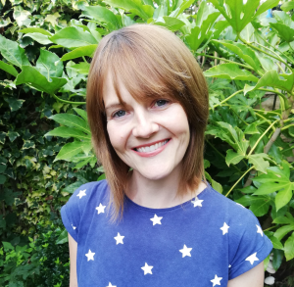

About Jen Carney (in her own words)
Jen Carney was born in a Lancashire a gazillion years ago.
She loves writing (obvs), doodling, walking and playing games.
Her favourite colour is green and, like Billie, she loves dismantling biscuits
A big believer in the power of funny books, Jen wrote the B.U.G. series to make people laugh while reflecting families headed up by same sex parents like her own.

Each school can order any combination of the following signed books at the event price of £6 per book (normally £6.99):

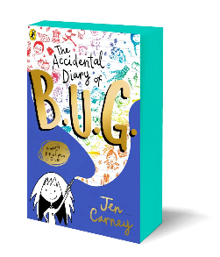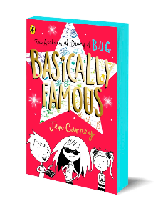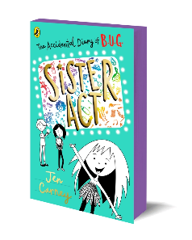

The Accidental Diary of B.U.G
Enter the hilarious world of Billie Upton Green . . . book 1 in the series, full of Billie’s laugh-out-loud observations and doodles! Billie takes it upon herself to show the new girl around school and teach her the Biscuit Laws. But then suspicion sets in. Doesn’t she know a little too much about the latest big school heist – the theft of Mrs Robinson’s purse…?

Basically Famous
Book 2. School just got INTERESTING. Not only is Billie’s class learning how to P.E.E. in the classroom (don’t ask), they now have some very important contacts in the TV world…it’s time for B.U.G. to make it BIG!

Sister Act
Book 3. There’s an exciting addition to the Upton Green family (and it’s not whatever Mr Paws has left on the living room carpet…).

Pupil Order Form
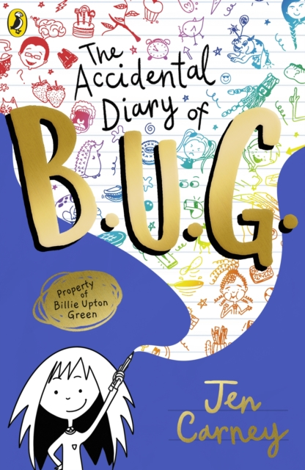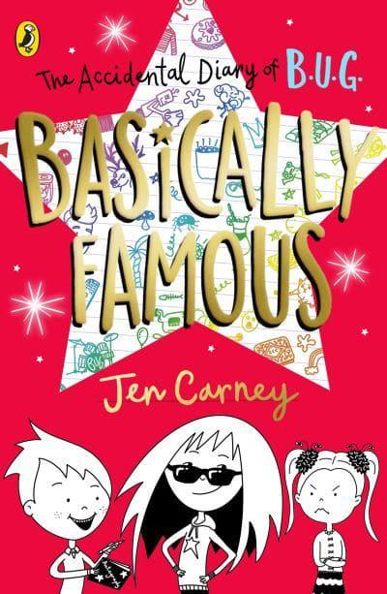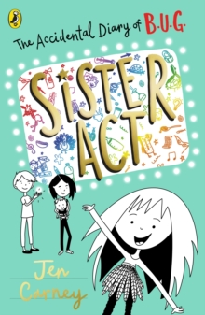

Enter the hilarious world of Billie Upton Green . . .

Please return form to school with payment by Weds 9th March.

Signed Books | Event Price | Tick to order
Accidental Diary of B.U.G (book 1) | £6
Basically Famous (book 2) | £6
Sister Act (book 3) | £6

Pupil Name & Class _______________________________________
School Name_____________________________________________
