Parent Survey
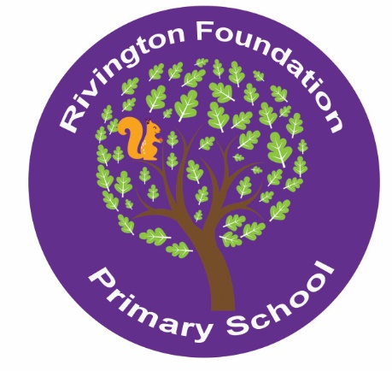

Parent Survey: School Vision Rivington Foundation
Our school vision is our shared aim for what we are all working towards in our school.
As a whole-school community, we are revisiting and updating our school vision to make sure it is still relevant to our shared aims.
Please help us to make sure that you are represented in our school vision by adding your ‘top three’ for each of the headings below. Just a word or two in each box is fine and you don’t need to write in all the boxes.
List three things that make our school special.

List the top three things about your child(ren)’s time at school so far.

Choose three words to describe what you want your child(ren) to experience at our school.

Choose three things you want your child(ren) to take with them when they
leave our school.

Is there anything else you want to add?

