Dara McAnulty – Wild Child event
Thursday 30 September

We are excited to let you know that our school will be taking part in a very special virtual event with Dara McAnulty, to celebrate his beautiful nature book Wild Child.
Dara McAnulty is a naturalist, conservationist and activist from Northern Ireland. He’s a truly inspirational 17 year old who has received awards for his conservation work, and has appeared on CountryFile and BBC Springwatch. He lives with his family and Rosie the rescue-greyhound at the foot of the Mourne Mountains in County Down.
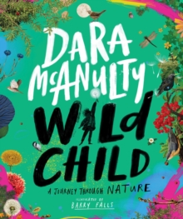
About the book WILD CHILD
WILD CHILD is illustrated in full colour by Barry Falls, and is divided into five sections: looking out of the window, venturing out into the garden, walking in the woods, investigating heathland and wandering on the river bank. Dara tells the reader about each habitat and provides fantastic facts about the native birds, animals and plants you can find there. Each section contains a discovery section covering natural phenomenon such as metamorphoses and migration, or categorization in the animal kingdom. The sections finish with activities to do at school or at home.
ebb & flo bookshop have invited us to this event and are offering books for sale at the
special event price of £12 (normally £14.99).
To order please complete the details below and return to school along with the correct payment,
by Monday 20th September. Books will be delivered to school as close to the event as possible.

 |  | Quantity required:
Wild Child | £12
Child’s name and Class

School name

