Baroness Floella Benjamin – Coming to England
Tuesday 11th May

We are excited to let you know that our school will be taking part in a very special virtual event with Baroness Floella Benjamin, to celebrate the publication of both her picture book Coming to England: An Inspiring True Story About the Windrush Generation, and the 25th anniversary edition of her ever-popular middle grade memoir Coming to England.
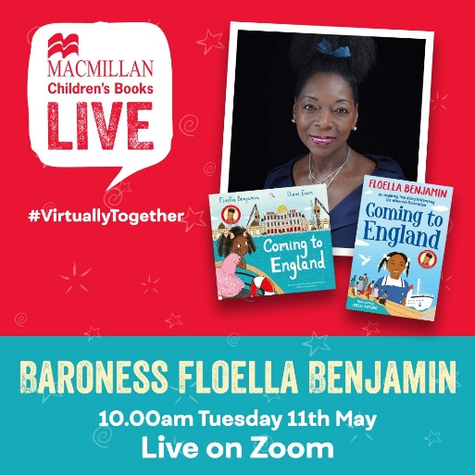
Follow ten-year-old Floella as she and her family set sail from the Caribbean to a new life in London. Alone on a huge ship for two weeks, then tumbled into a cold and unfriendly London, coming to England wasn't at all what Floella had expected . . . What will her new school be like? Will she meet the Queen? Filled with optimism and joy, yet deeply personal and relevant, children will resonate with Floella's experiences of moving home and making friends…

ebb & flo bookshop have invited us to this event and are offering books for sale at the
special event price of £6 (normally £6.99).
To order please complete the details below and return to school along with the correct payment,
by Thursday 29th April. Books will be delivered to school as near to the event as possible.

Coming to England picture book (Foundation & KS1) | £6 | Quantity required:
Coming to England chapter book (KS2) | £6
Child’s name and Class

School name

