In celebration of Children’s Mental Health Week (1st-7th February 2021).

Why not plan to use our free videos and help children Express Themselves!!

Children are struggling to express their emotions during this time, so please utilise our specialist, fun and engaging videos next week to bring out their creativity and confidence.

How can YogaBugs help children express themselves?
Take a look at the video below to find out! https://www.youtube.com/watch?v=A5TtAHKv8w0&safe=active

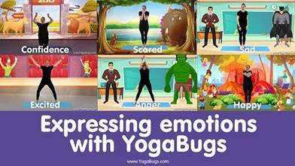
How do I access the free videos for children’s mental health week?

• Simply click this link https://vimeo.com/showcase/8056777
• And enter your Password is: emotionsneedtobeexpressed

