Active learn Primary

Type active learn primary into google

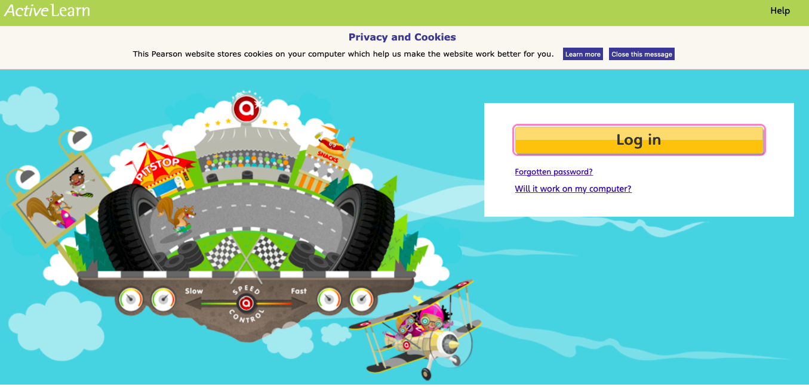

Logging in
Your teacher will give you a username, password and a four letter school code.
Click the “Log in” button. You will be taken to a new page to sign in
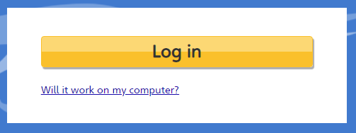

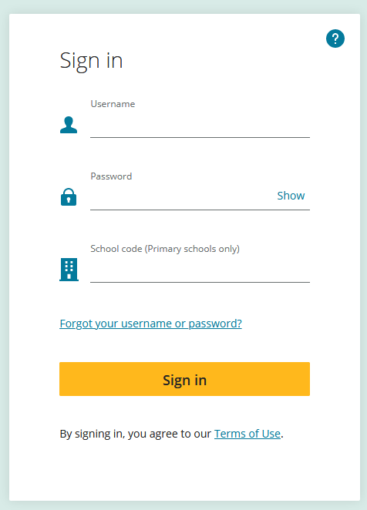

Your login details are the same as Purple Mash with 2020 after your password. The password had to be at least 6 characters long.

The four letter school code is:
rivi

Your child has been allocated some books to read some year groups I have guessed a little as the details I need are at school – I had access to some but not all. Give them a go, the teachers will be adding more in due course.

Any problems email school and I will do my best to sort them out.

Mrs Whittaker

