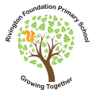
Rivington Reading Award Scheme
Review/Recommendation EYFS/KS1
Your name:………………………………………….Year group:……………………………………
Title:……………………………………………………………….Author:………………………………
Pages:………………….. Let’s Read/Reading list? (Circle: Yes/No)
Fiction/Non-Fiction?...................................................................
What was it about? (Brief synopsis) (Adult can scribe if needed)
................................................................................................................................................................................................................................................................................................................................................................................................................................................................................................
How many stars? (colour/shade)

