Below is a comprehensive guide for parents which offers advice and guidance on how children and young people use modern technologies to access online material and ways to ensure young people understand how to adopt safe practices.

Learn about it. Talk about it. Deal with it.
Here are some useful resources to help you do just that and make informed choices about your children’s online safety. You’ll find links to more relevant resources throughout our site. Click the logo to find out more.

Facebook make changes to privacy settings for 13 to 17 year olds - click here to find out more
A Comprehensive range of support materials from Childnet. The Parents and Carers section is particularly useful and contains lots of advice on what you need to know. Click the logo on the left to visit the site.

Please find below a range of excellent resources that can be used to make young people aware of potential issues that could affect their safety.

CEOP now have their own Youtube Channel which has links to some fantastic resources for both parents and young people. The content is suitable for a broad age range and should be used to discuss the issues and potential dangers of using online technologies inappropriately.
click here to find out more

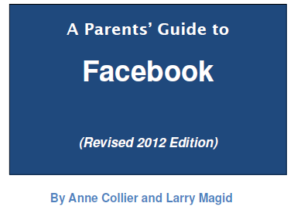 | A revised and updated Facebook guide for parents from Connect safely. Click the logo to view

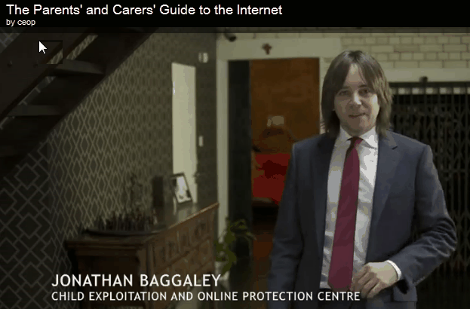 | CEOP -The Parents and Carers Guide to the Internet.  This online guide aims to equip you with the tools to have those tricky conversations with your children and keep your family safe online.
Part of the BBC website with help & support for all aspects of internet safety
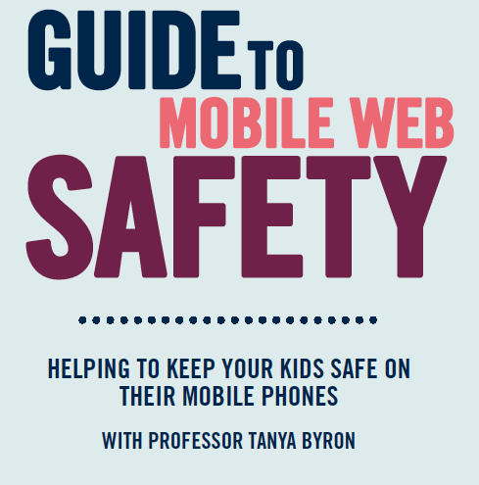 | A collaborative document designed to help parents keep children safe when using mobile technologies.  click the logo to find out more
New 'Know IT All' resources for parents and carers highlights the gap that exists between children’s real experience online and adult awareness of these experiences. The site contains information about positive ways young people are using different technologies, what the risks are to users and it outlines practical advice in avoiding or minimising risks when using online and mobile technologies.
Click either of the logos to find out more

We get a lot of questions about particular devices that children are using or asking for. This guide has been created to answer these questions and introduce some of the most popular devices, highlighting the safety tools available and empowering parents with the knowledge they need to support their children to use these technologies safely and responsibly. Click the logo for more info.
In the 'I have Kids' section of the Kids Smart website there are some excellent resources for children and parents. Click the logo to find out more

Google Safe Search is designed to screen sites that contain sexually explicit content and remove them from your search results. While no filter is 100% accurate, Safe Search helps you avoid content you may prefer not to see or would rather your children did not stumble across. Click the logo to find out more
Facts and information about the PEGI game ratings.
BBC Webwise provides information and activities to help you get the most out of the internet, including safety and privacy for both adults and children.
Brush up your computer skills with
This is a website designed to help people take their first steps with computers and the internet. Registration is free and allows users to access a wide range of online courses that cover everything from turning a computer on to surfing the internet.

Guide to Facebook Security |
(1484.5k)
This guide should help you to understand what 'Facebook' is all about, and how to use security settings to protect your personal information.

Online Gaming - Help for Parents
An often overlooked area of eSafety includes the use of video games consoles and in particular, online gaming by children and young people. The links below provide some useful information to support parents, including how to address issues such as restricting access to age-appropriate games or limiting the amount of time children can play for.
Online Gaming: Help Kids Play It Safe (Microsoft):
The Good Gaming Guide (Pegi):

Parental Information Sheets - Becta
The following are a number of Activity Cards produced by colleagues at Becta.
Parents As Partners - Search smartly for information
Parents As Partners - Teach your child to use online content responsibly
Parents As Partners - How to assess online information
Parents As Partners - How to make the most of Online Communities

Parent Information From Orange
Extract from the Orange Website: Like our other films, Safety Online & Incoming Message, this is designed to generate debate and discussion around the fears and concerns parents have about their children and their online behaviour. The film depicts children returning home from school, dropping their school bags and going straight to their rooms to go online. The resulting discussions from their parents are seemingly linked by a common concern about what their children may be up to. There are some positive messages about the internet as well as the negative so that the film has some balance. The call to action is for parents to download a copy of the Parents Guide (What Parents Need to Know) which as you know was re-launched in the summer.

http://www1.orange.co.uk/safety/ (see the film link on the right hand side of the page)

Know IT All SEN Resources
Whilst the Know IT All parental tools from Childnet International are an excellent set of resources, the link below relates specifically to the SMART rules in BSL.
http://www.childnet.com/kia/sen/bslrules.aspx

A useful document from next Generation Learning giving lots of parental advice on keeping children safe on the Internet.  click the image to find out more | 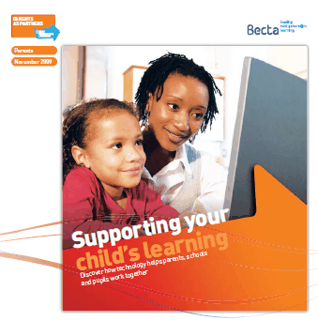

Sexting
'Sexting' is a relatively recent development that involves the sending of sexually explicit messages or images electronically (particularly between mobile phones) and has recently received an increased profile across the UK media (e.g. http://news.bbc.co.uk/1/hi/education/8182033.stm)
NetSmartz.org site gives parents advice on how to address Sexting with their children.

