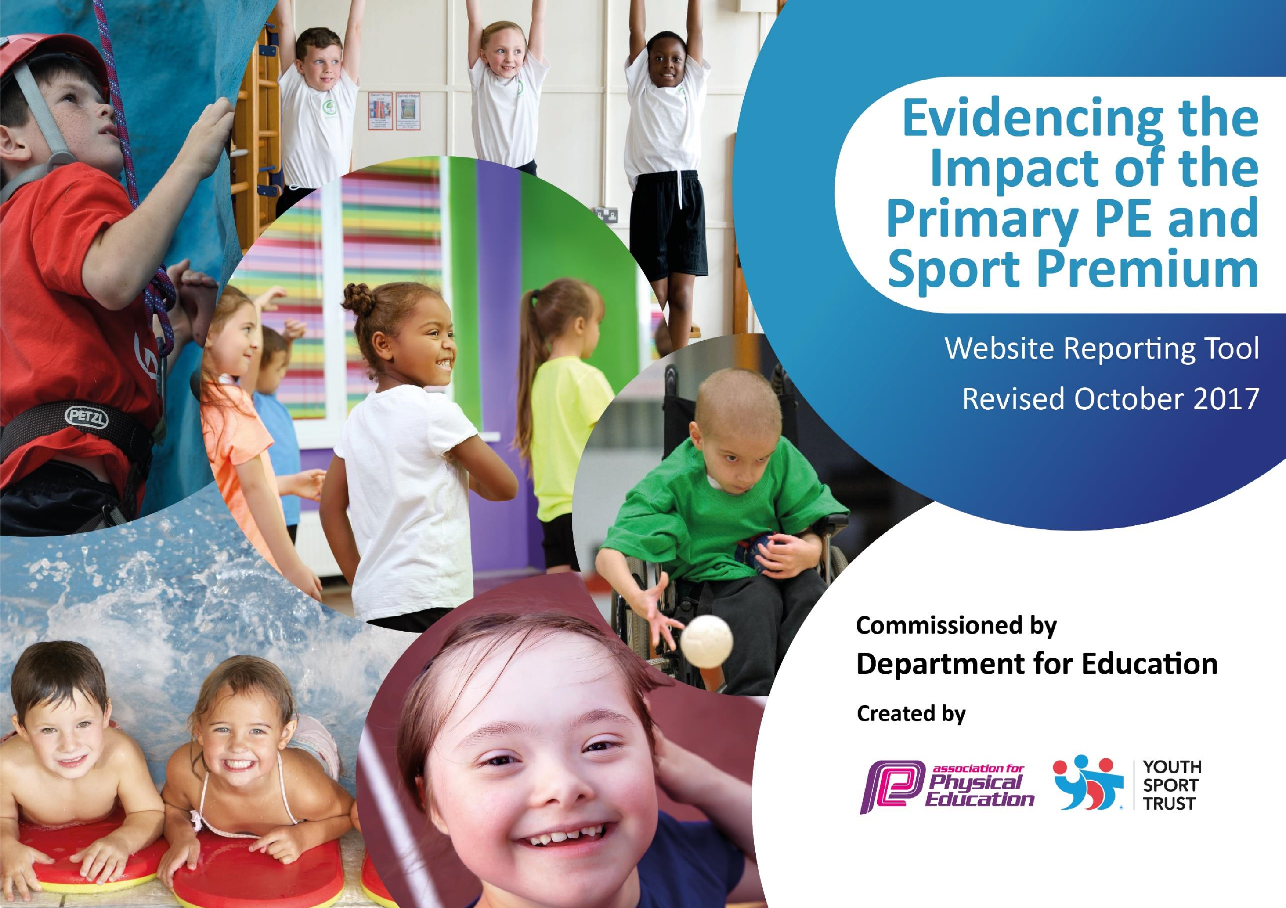

Using the 5 key indicators from DfE, our development needs have been prioritised for the pupils. Current need, planned spending for 2017-18 and priorities for the future are detailed below.

Key achievements to date: | Areas for further improvement and baseline evidence of need:
All Key Stage 2 children leave our school with swimming abilities that are beyond the national curriculum expectations.  School Games Award at Bronze level in summer 2019.  Forest Schools accredited0020 instructor on school staff. | Many Reception and Key Stage 1 children have private lessons and can swim competently before the school lessons. The age at which school swimming takes place has recently been reduced from Y5/6 to Y3/4. This also allows time for those who have not met the expectations to continue with swimming lessons.  More pupils to take part in more inter school competitions and silver level to be achieved in summer 2020.  All pupils to take part in 15 minutes of activity per day in order to increase their general fitness and levels of activity.  Develop a wider school curriculum for swimming, cycling and orienteering in order to suit the restraints of the building.  Further whole- school provision with more specialist teachers particularly for dance and gymnastics.  Forest school- pupils will explore their creativity and develop confidence, resilience and curiosity- holistic development.

Meeting national curriculum requirements for swimming and water safety
What percentage of your Year 6 pupils could swim competently, confidently and proficiently over a distance of at least 25 metres when they left your primary school at the end of last academic year? | 100%
What percentage of your Year 6 pupils could use a range of strokes effectively [for example, front crawl, backstroke and breaststroke] when they left your primary school at the end of last academic year? | 100%

What percentage of your Year 6 pupils could perform safe self-rescue in different water-based situations when they left your primary school at the end of last academic year? | 100%
Schools can choose to use the Primary PE and Sport Premium to provide additional provision for swimming but this must be for activity over and above the national curriculum requirements. Have you used it in this way? | Yes- in the local area, there is a canal, river and quarry. With increased funding, we intend our pupils to be taught beyond the national curriculum requirements.

Action Plan and Budget Tracking
Capture your intended annual spend against the 5 key indicators. Clarify the success criteria and evidence of impact that you intend to measure to evaluate for students today and for the future.

Academic Year: 2018/19 | Total fund allocated: £15, 070 | Date Updated: 22/7/19
Key indicator 1: The engagement of all pupils in regular physical activity – Chief Medical Officer guidelines recommend that primary school children undertake at least 30 minutes of physical activity a day in school |  |  |  | Percentage of total allocation:
 |  |  |  | 9%
School focus with clarity on intended impact on pupils: | Actions to achieve: | Funding allocated: | Evidence and impact: | Sustainability and suggested next steps:
Introduce the daily 15 minute exercise which is additional activity for all pupils every day.  Audit and restock playground equipment with resources to encourage physical activity e.g. skipping ropes, hoops, timers.  Playground to be cleared to increase space for play. Trees to be cut down and trimmed.  Sports Services bought into from CSSP up to Level 2 including all competitions, festivals and leagues.  PE services bought in from CSSP | Identify activities with staff.  Discuss clothing and footwear with staff and pupils.  School Council to audit and survey children for required resources. RC to purchase those requested and others using money raised from Sports For Schools event.  Once cleared - Site manager/HT to inspect weekly.  The large majority of pupils will have taken part in a sporting event outside of school.  All children have a minimum of 2 hours quality PE lessons per week. | £1100 | All pupils involved in 15 minutes additional physical activity every day.  More pupils are actively playing at lunchtime, especially KS2.  An increased area of play leads to further physical play at  lunchtimes  A more inclusive approach, encouraging all children of all abilities to engage in sport/ physical activity. Increased confidence in sporting activity.  Children’s functional skills are well-developed. Increase in confidence, enjoyment and engagement in PE- pupil interviews, monitoring e.g. walkthroughs.  WIDER IMPACT AS A RESULT OF ABOVE:  Pupils are more active in PE lessons and have increased stamina.  Attitudes to learning improve and better concentration in lessons. | Daily exercise (brisk walking or running) firmly embedded for all classes.  Sports Committee/ prefects to look after resources and report damages. Next step- introduce play leaders, older pupils on playground.  On-going upkeep necessary.

Key indicator 2: The profile of PE and sport being raised across the school as a tool for whole school improvement |  |  |  | Percentage of total allocation:
 |  |  |  | 6.4%
School focus with clarity on intended impact on pupils: | Actions to achieve: | Funding allocated: | Evidence and impact: | Sustainability and suggested next steps:
Celebration assembly weekly used to raise awareness of the importance of PE and sport in and out of school time. Pupils encouraged to share their achievements.  New notice board outside to raise the profile of sport and celebrate achievements. Display board created solely for sporting achievements/activities in school.  PE services bought in from CSSP including PALS. | Staff give certificates for pupils as appropriate. Parents and pupils reminded to share achievements using the weekly newsletter.  Replace board - display photographs, certificates etc. Also display information regarding clubs on this board and the external noticeboards.  All children to have a minimum of 2 hours quality PE. Coverage of the national curriculum- using Lancashire rolling programme.  Staff further developed by observing qualified, experienced specialist coaches.  Children in Year 5/6 become playground leaders- trained to encourage children to participate in active play. | £0  £8280  £200 | Parents attend assemblies and send achievements in with notes if necessary. Most pupils take part in a celebration assembly over the course of the year.  The board celebrates success and participation, raises self-esteem and encourages others to take part.  .  WIDER IMPACT AS A RESULT OF ABOVE:  Pupils are keen and proud to be involved in celebration assemblies.  Photos on display impact on confidence and self-esteem which impacts on learning.  Children are more confident in being physically active which results in increased enjoyment and engagement in PE. | No cost so easily sustainable whilst popular with pupil sand families.  Low cost, ongoing reproduction costs can be absorbed.  Children who are more proficient in fundamental movement skills are more likely to choose to be active throughout their lives.

Key indicator 3: Increased confidence, knowledge and skills of all staff in teaching PE and sport |  |  |  | Percentage of total allocation:
 |  |  |  | 40%
School focus with clarity on intended impact on pupils: | Actions to achieve: | Funding allocated: | Evidence and impact: | Sustainability and suggested next steps:
To improve progress and attainment of all pupils, Chorley School Sport Partnership (CSSP) provide a specialist teacher/ coach to cover the six main areas of the PE curriculum each year. Teaching and non-teaching staff are present throughout the lessons.  Staff to observe teaching of specialist coaches/teachers.  National Sports Week- teaching staff directed by RS to carry out PE sessions to apply what they have learnt from observations.  Support staff encouraged to run extra-curricular sports clubs e.g. running club.  Subject leader support from CSSP.  Playground leaders | Buy in to CSSP to access support in: Gymnastics, Dance, Invasion Games, Target, Striking and Fielding and Athletics. Specialists plan all curriculum sessions to meet the needs of your pupils and assess against the core tasks within the Lancashire Scheme of Work. Champions of  Character, School Games Level 1 Events and Change 4 Life Activities are embedded into the delivery programme.  PALs training | £8280  £200  £600  £200 | Increased subject knowledge and confidence for staff after working closely with a specialist teacher.  Pupils enjoy being more physical at lunchtimes in a focused way. They can measure progress and improvements themselves with timers etc.  Playground zones established so that pupils experience a range of physical activity during play times.  All staff: teaching assistants and teachers feel more confident with a more competent skill set to be able to deliver extra PE sessions to enhance the curriculum provided by CSSP.  (Staff ability to deliver high quality PE maintained.)  WIDER IMPACT AS A RESULT OF ABOVE:  Pupils level of concentration improves during afternoon sessions as a result of being more active at lunchtime.  Pupils discuss feeling benefits of being more active.  Mental health and well-being of pupils positively increased due to the effects of physical exercise. | This will lead to sustainability as all staff will be supported to deliver PE more confidently and with more knowledge and skills.  Upskilling of welfare staff will lead to improved activity for pupils which will have a long term effect and benefit to all pupils.

Key indicator 4: Broader experience of a range of sports and activities offered to all pupils |  |  |  | Percentage of total allocation:
 |  |  |  | 33.4%
School focus with clarity on intended impact on pupils: | Actions to achieve: | Funding allocated: | Evidence and impact: | Sustainability and suggested next steps:
Offer a wider range of activities as part of the PE curriculum in order to provide all pupils with new activities and sports which have not been experienced.  Year 2 and Gifted and Talented assessments.  Encourage cycling in order to reduce levels of inactivity. | Buy in to CSSP sports services: festivals, level 1 and 2 competitions and leagues.  Data used to plug gaps through interventions in sessions.  Bikeability course offered to all Y5 and 6 pupils (run by CSSP) to be arranged annually. | £1100  £150  Included in CSSP SLA. | Children have greater opportunity to take part in sporting events: gifted and talented have opportunity to develop and apply their skills. Children who have low confidence and ability have chance to develop their skills and confidence through taking part in festivals.  Children’s functional skills have developed through targeted intervention to prepare them for further application in KS2.  Mini-wheelers- key aspects of static and dynamic balance are mastered.  OAA days- Pupils can participate in pursuits that they previously lack the opportunity to experience. Those showing a talent or natural ability will be encouraged to participate further through a local club for example.  Y5 pupils understand the importance of wearing safety helmets and clothing, can maintain their bicycles and use them safely in the local streets.  WIDER IMPACT AS A RESULT OF ABOVE:  To promote physical activity in the children and make a significant difference contribution to the reduction of sedentary behaviours. | Following taster sessions in 5 different activities/sports, many children will go on to  pursue these as hobbies or for lessons/clubs.  Participation will be monitored by the subject leader.  Use of data monitored by RS.  Continue to benefit form CSSP provision. If this is discontinued, revert to the similar, previous Safer Cycling  scheme run by school staff.
Key indicator 5: Increased participation in competitive sport |  |  |  | Percentage of total allocation:
 |  |  |  | 2.9%
School focus with clarity on intended impact on pupils: | Actions to achieve: | Funding allocated: | Evidence and impact: | Sustainability and suggested next steps:
CSSP Sports Services buy in: festivals, competitions and leagues.  Fizzytree Theatre company in to deliver performing arts workshops in curriculum time (link to Book Week) and in after-school club.  Taekwondo, Judo and Fencing clubs across the year.  Established sports activities including an element of competition amongst the pupils in school to continue- Football, TeamTheme, DanceTalent, rugby, rounders and attendance for groups of pupils (disadvantaged, SEN etc monitored).  Engage more pupils in inter school competitions, particularly those who are disaffected and reluctant to participate in sport. | School staff to continue to run clubs with parent helpers if required.  Sports Specialist weekly clubs to continue for the 6 main areas of PE.  External agencies to be invited to run clubs as required.  CSSP organise wider competitions for school to access- PE subject leader to organise throughout the year.  Examples:  Cross country  Benchball  Athletics  Swimming gala  Splash (diving)  Orienteering  Trigolf  Relays  Hockey  Rounders  Superstars  Also- football tournament held annually between 5 local schools. | £1100  Free (pupil premium children paid for).  Free for school.  Sports kit and transport to events, admin for letters, organisation of events etc. | Attendance to be monitored to establish participation rates for groups, gender, SEN, disadvantaged as well as whole school participation rates.  Improved standards in curriculum PE, increased attitude towards physical activity, parents showing more interest in sport and PE.  WIDER IMPACT AS A RESULT OF ABOVE:  Staff note increased levels of physical activity and fitness levels, eg during the 15 minute daily exercise.  Concentration levels increase as physical activity levels increase. | Dependent on willingness of staff to give up their time freely after school to run some of these activities. Recruitment of parents to help will result in activities being able to run in  the future should staff leave  Subject Leader takes on the organisation of this as part of their role.  Successful competitions to be entered annually and additional ones as CSSP provide and organise them.

Other Indicator identified by school: Additional swimming |  |  |  | Percentage of total allocation:
 |  |  |  | 8.3%
School focus with clarity on intended impact on pupils: | Actions to achieve: | Finding allocated: | Evidence and impact: | Sustainability and suggested next steps:
To ensure 100% of pupils leave Year 6 meeting the statutory requirements of the national curriculum for PE and that at least 90% increase their attainment and achieve:  50 metres distance  Can use a range of strokes eg breaststroke, crawl and backstroke Can perform safe self rescue so that they are confident and safe in water. Rivington has a canal, river and reservoir, all of which pose a danger to non or weak swimmers. The locality of the school has resulted in water safety and competence being prioritized. | Two week block for Year 4 CSSP to provide lessons to include stroke technique and safe self rescue. | £1928  For transport and swimming lessons. | Target of 100% Y6 to meet national curriculum requirements. Target of at least 90% to meet additional requirements. | Governors have committed funding to the swimming programme prior to Sports Premium funding and will continue to do so. They are keen for younger pupils to attend lessons with school as many learn to swim privately at an even younger age.

