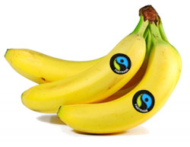
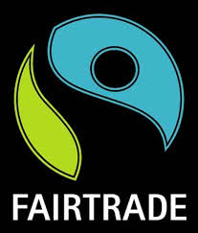
Fairtrade Primary School Conference – 2016

On Friday 6th February four children from Year 6 accompanied myself to County Hall in Preston where we attended a conference all about Fairtrade. We listened to talks from:
- Kathy Wise of the Fairtrade Foundation
- Cat Smith the MP for Lancaster and Fleetwood who talked to the children about ‘Fairtrade to Parliament’.

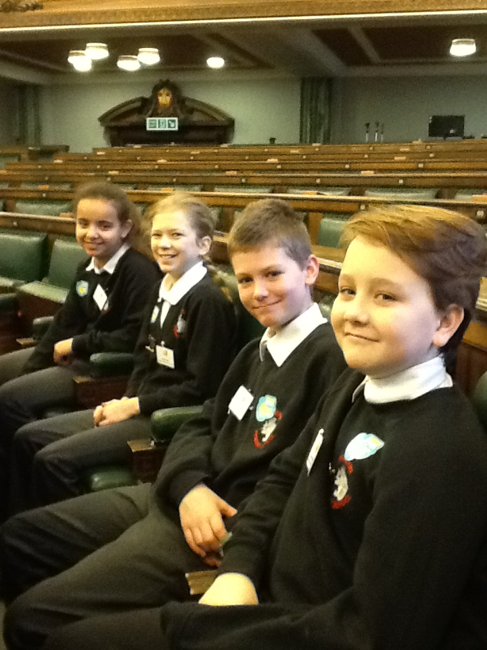

The children then took part in three different activity sessions.
Session 1
In this session we had to design our own food product that had to contain at least one Fairtrade item. The children worked as a team and very quickly came up with the idea of a breakfast cereal type bar.
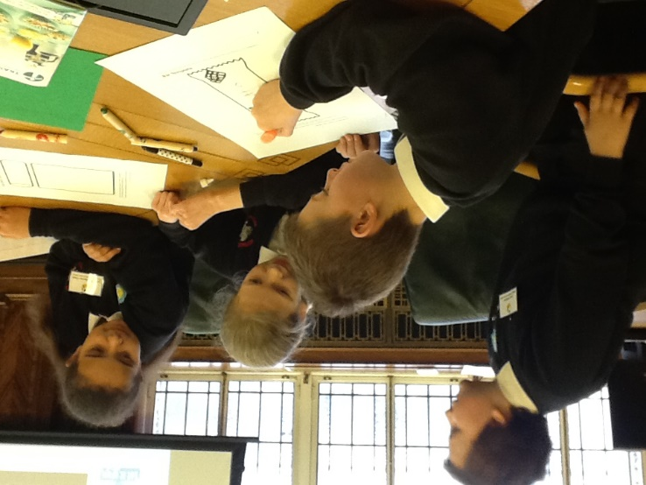
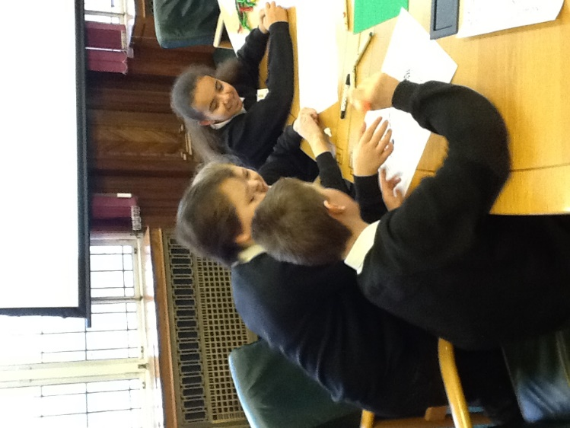

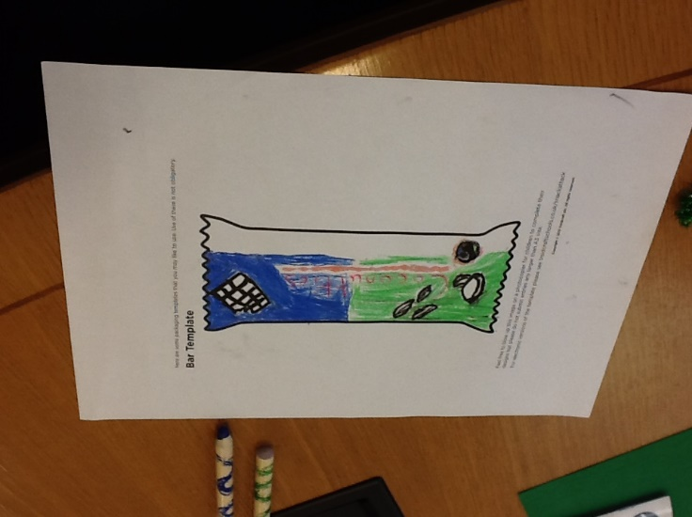
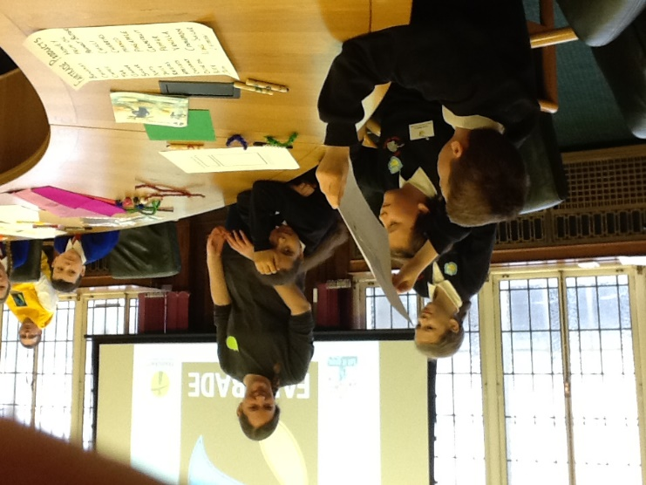

The children had to feedback their idea to the rest of the group and explain what Fairtrade item/s they had included and what the product was they had designed and who it was targeted at.

Session 2
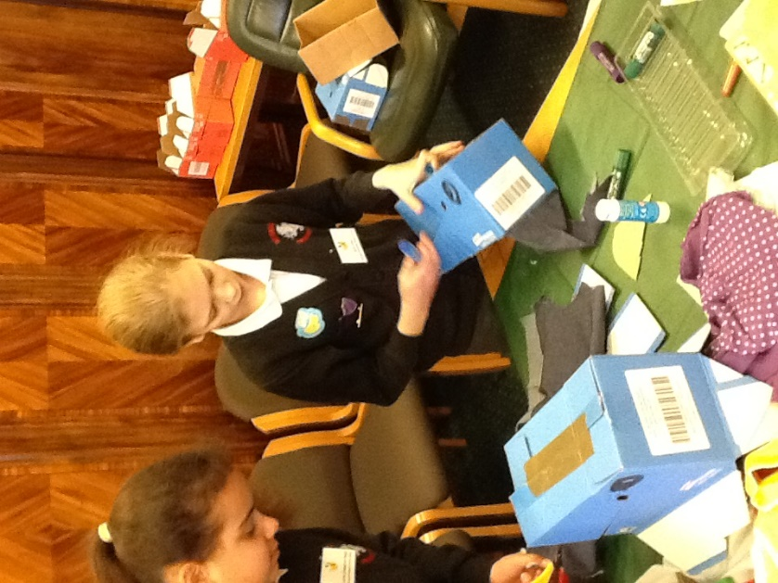
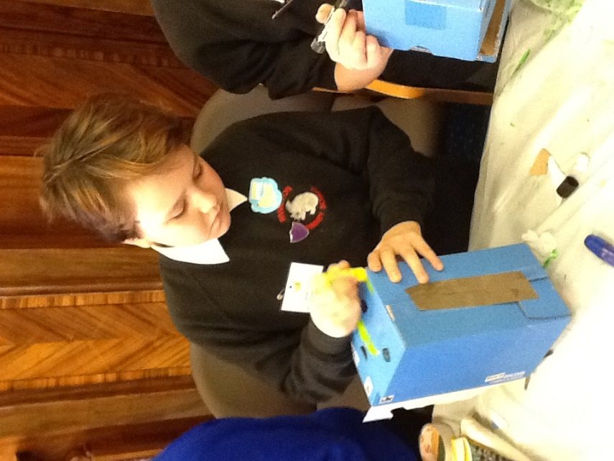
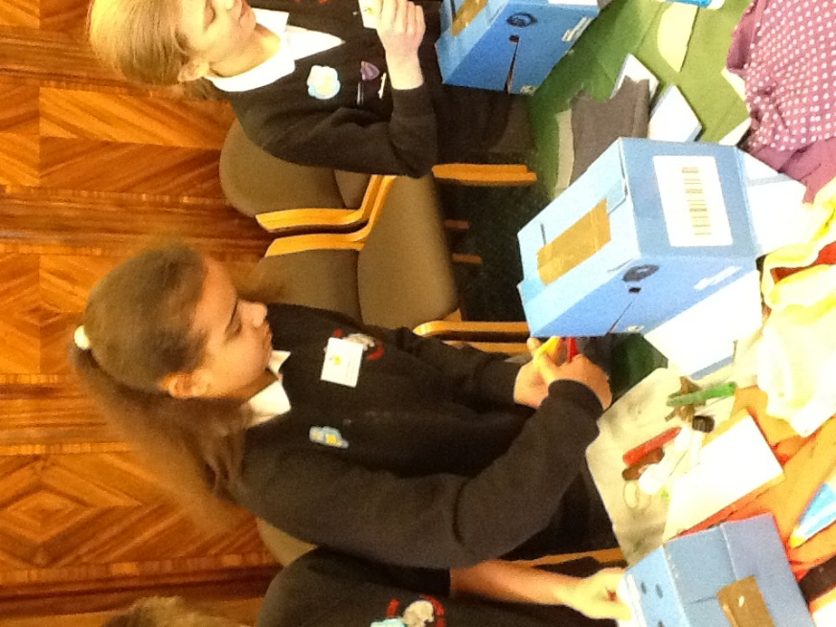
In this session the children learnt about how areas of the Amazon rainforest are being affected and how Fairtrade companies are trying to help. The children had great fun using the resources to create their own jungle animal mask.
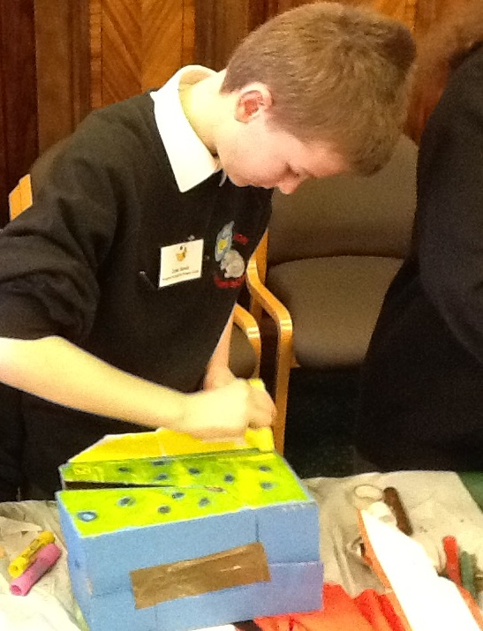
Session 3
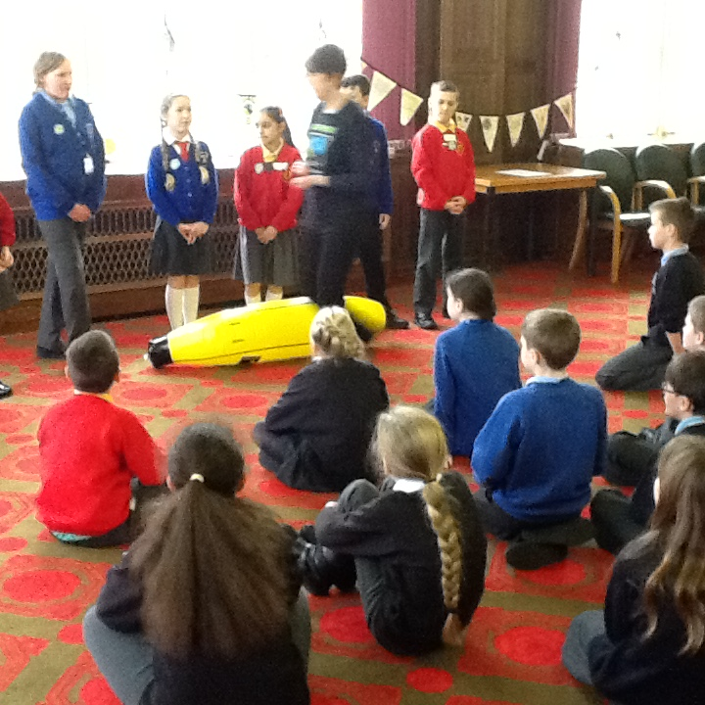
Our final session of the day looked at the journey of a banana, from the farmer growing them to being bought in a UK supermarket. The children were put into smaller groups and given an aspect of the journey to look at and to think about the jobs that need doing and the people involved at each stage. Finally the children were then given an idea of how much each person got paid for their part of the process. With the farmer getting the least money. The leader of the session explained how Fairtrade was changing this process and that every part of the process was reflected financially and that each person got a fair price/wage for their role.

Overall the children had a great day and learnt lots about Fairtrade to feedback to the rest of the school.

